Lab 07 Submission

Lauren Hammond

Code:

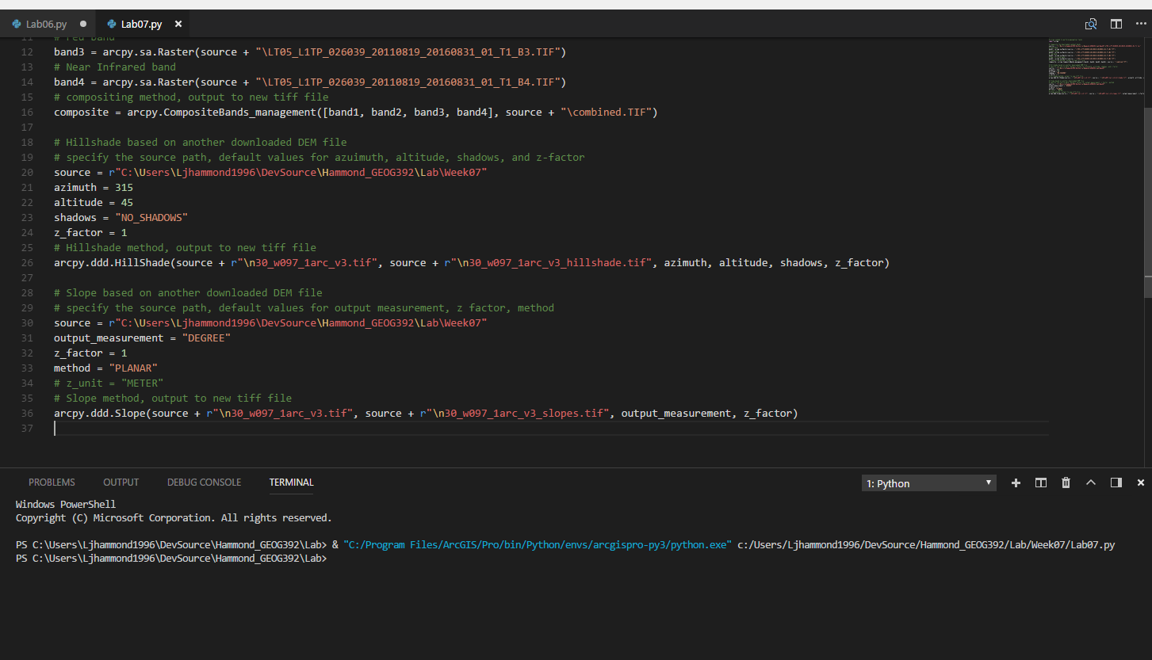

Composite: Bands 321 displayed as RGB, band 4 is also included in the listing but not displayed

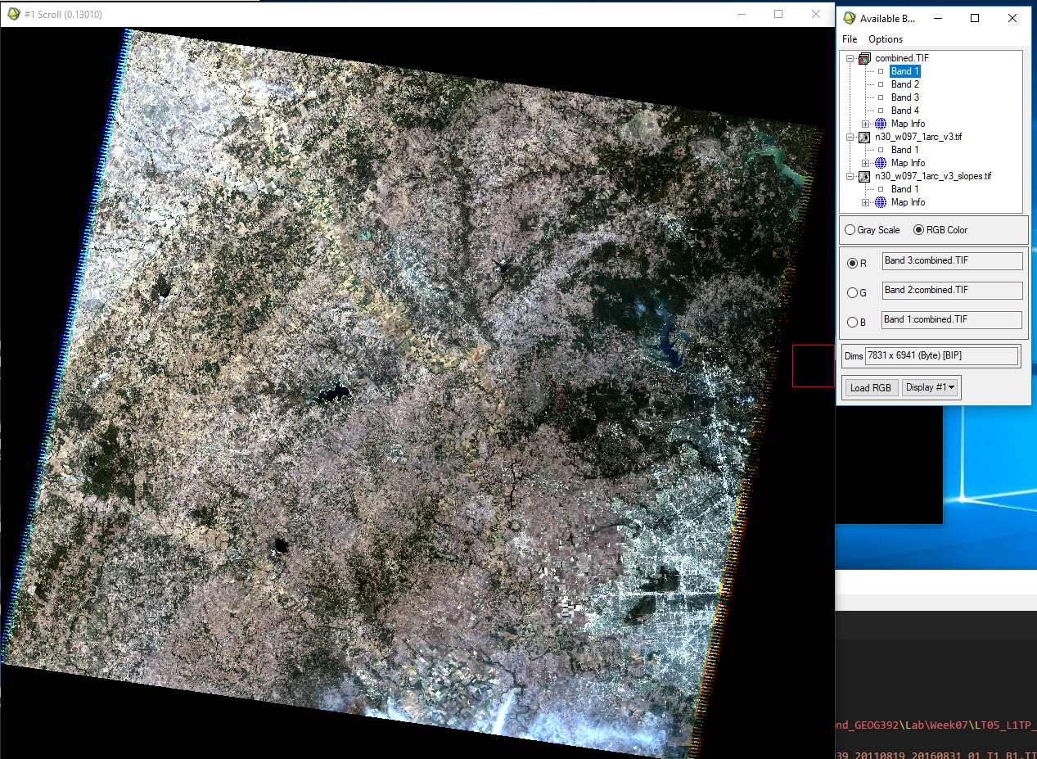

Hillshade: My result on the left, the original DEM on the right

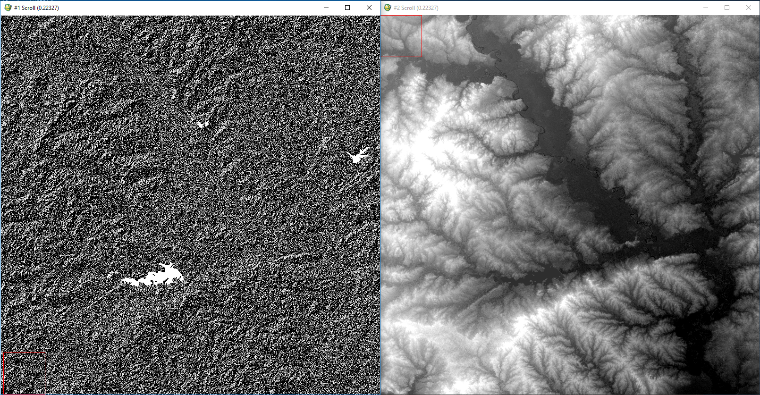

Slope: My result (linear 0-255 enhancement, linear 2% enhancement) on left, original DEM on right

